Git Hands-on 5: Clean Up & Push to Remote
Objective
Verify the local master/main branch is clean, pull from the remote repository, push any pending changes, and confirm that updates are reflected on the remote.

1. Prerequisites
- Git installed and configured.
- Local repository at C:\Users\choll\GitDemo.
- Remote repository linked (GitLab or GitHub).

2. Steps
1. Ensure You Are on master/main and Working Tree is Clean
cd /c/Users/choll/GitDemo
git status
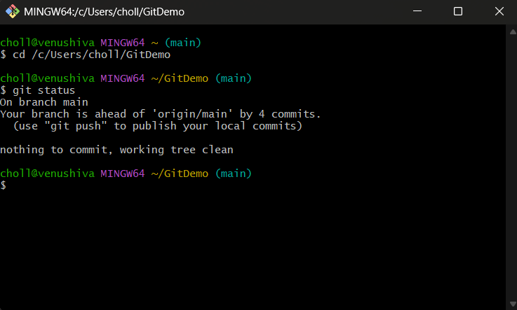

2. List All Local and Remote Branches
git branch -a
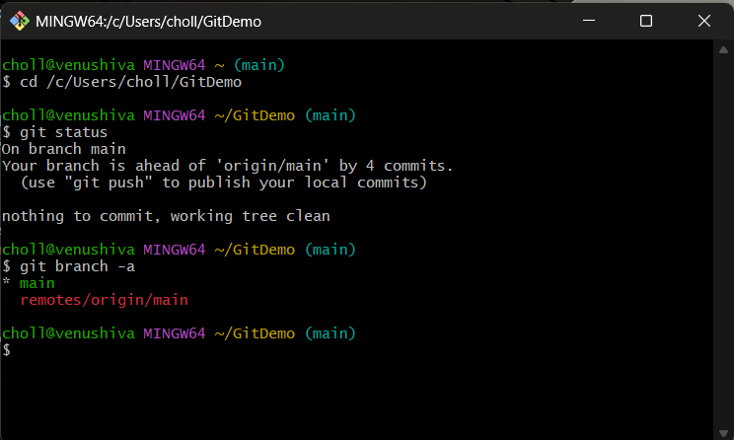

3. Pull the Latest Changes from Remote
git pull origin main
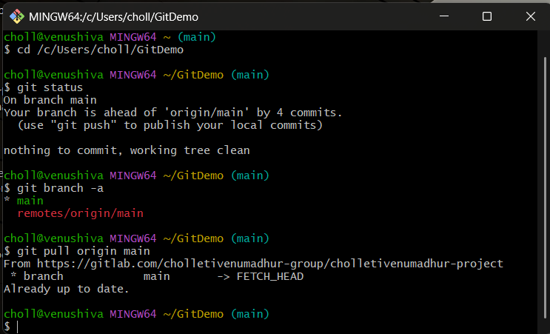

4. Push Any Pending Changes to Remote
git push origin main
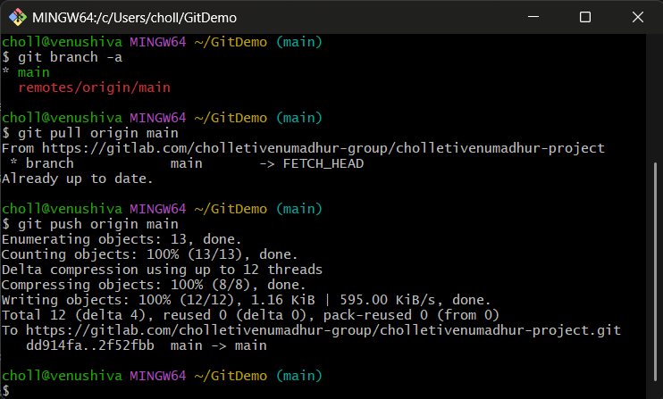

5. Verify Changes on Remote
- Open your GitLab/GitHub repository in a web browser.
- Confirm that commits and files from recent labs are visible.
